KGATLENG REGION

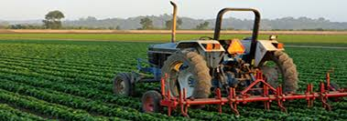

END OF TERM 2

2017

AGRICULTURE 5

NAME:____________________________________________________________________
STANDARD:__________________________________________
SCHOOL:_____________________________________________________
- 1.1.1.1 Define Agriculture.
_________________________________________________________
__________________________________________________________
__________________________________________________________ (1)

- 2.1.1.1 Explain how soil is formed.
_____________________________________________________________________________________________________________________________________________(1)

- 2.2.1.1 State two importance of soil.
i)____________________________________________________________
_____________________________________________________________

ii)____________________________________________________________
__________________________________________________________(2

- 2.3.1.1 Explain soil fertility?
_____________________________________________________________________________________________________________________________________________(1)

Use the pie chart to answer question 5

- __2.2.1.2 Which letter in the diagram of constituents represents 45%?
___________________________________________________________________(1)
- 2.2.1.1 State the other three (3) soil constituents not mentioned above.
i)______________________________________________________
ii)______________________________________________________
iii)____________________________________________________ (3)

Pule did the following experiment.
- He put some soil in a transparent container. He poured water into the container then bubbles started to show up from the soil in the container.

- 2.2.1.2 What do bubbles in this experiment prove?

_____________________________________________________________________(1)

- Neo’s seedlings are ready to be transplanted, which garden tool should she use?
_____________________________________________________ (1)

Read and answer the questions 9 and 10 below
Mrs Molemisi has discovered that some of her field crops are not growing well. She ended up putting some fertilisers in order to have a good yield. She only managed to get kraal manure and failed to get artificial fertilisers.

- 2.3.1.5 State one advantage of kraal manure and one advantage of artificial fertilisers.
  - Animal fertiliser: _____________________________________________(1)
  - Artificial fertiliser: ______________________________________________(1)
- Which fertiliser can quickly dissolve in water and be used by plants immediately?
__________________________________________________________________(1)

Use the pictures below to answer question 13 and 14
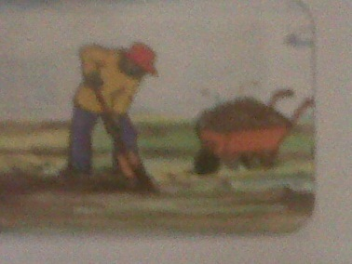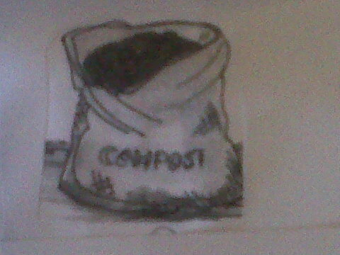
A B
- Fertiliser A is ______________________________________________(1)
- Fertiliser B is _______________________________________________(1)
- Explain Compost Manure.
_____________________________________________________________
_____________________________________________________________ (1)
- 2.3.1.6 State two (2) disadvantages of inorganic fertilisers.
___________________________________________________________
___________________________________________________________(2)
3.1.1.2 Write the difference between plant A and plant B using the pictures below.
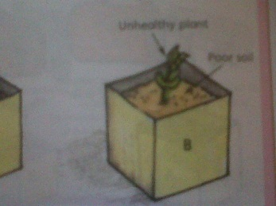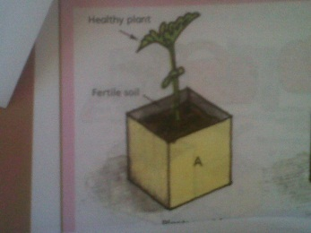
- A._____________________________________________________ (1)
B._____________________________________________________ (1)

- What are the two conditions needed for seed germination?
    - ________________________________________________ (1)
    - _________________________________________________(1)
Mr Mooketsi, a vegetable farmer in Sehitwa farms was applying fertilizers in a furrow along the row of seeds during planting.
- (i) Which type of fertilizer application was he using? (1)

(ii) What do you call a method of scattering or spreading of fertilisers on top of the soil?
(1)

3.1.1.3
Observe the pictures below and answer the question. Complete the question/statement.
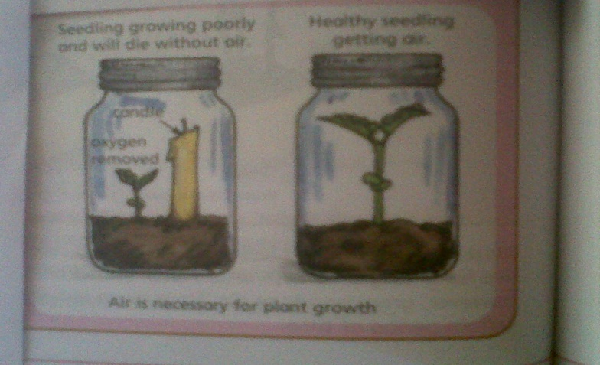

- Why do plants need carbon dioxide?
__________________________________________________________(1)

- 2.3.1.1 State two ways in which soil fertility can be increased
- ___________________________________________________(1)
- ___________________________________________________(1)
- 1.1.1.4 State any two importance of Agriculture in Botswana.
    - ____________________________________________________________________________________________________(1)
    - ____________________________________________________________________________________________________(1)
- 1.1.1.2 Name three branches of Agriculture.
    - _________________________________________________(1)
    - _________________________________________________(1)
    - _________________________________________________(1)
- 1.1.1.9 Name 3 careers in Agriculture.
    - _________________________________________________(1)
    - _________________________________________________(1)
    - _________________________________________________(1)

- 1.1.1.6 Write three (3) problems faced by farmers in Botswana.
    - __________________________________________________
    - _________________________________________________(3)
    - ___________________________________________________
Farmer X supplies the needy with sour milk from his goats.

- 1.4.1.1
    - Which type of bio- technology did he use to produce sour milk?
______________________________________________ (1)
    - Which type of bio-technology is used to produce cheese?
_______________________________________________(1)

- 1.2.1.2 Name the given farm tools.
- 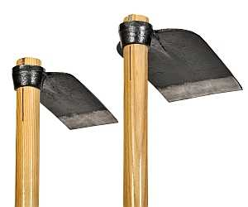 B) 
a)__________________________________________________(1)
b)__________________________________________________(1

26. Name two farm implements.
- i_______________________________________________________(1)
ii______________________________________________________(1)
b) 1.3.1.4 Give three proper ways of caring for the above named farm implements.
i) ________________________________________________ (1)
ii) _______________________________________________ (1)
iii)____________________________________________________(1)

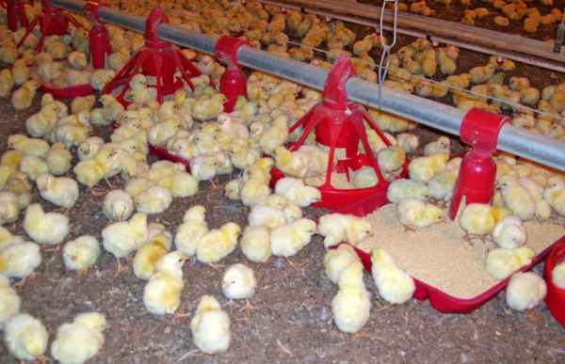

- 1.1.1.3 a) Which system of Agriculture is shown by the picture above?
_____________________________________________________ (1)
b) Describe the system mentioned.

(1)

AGRICULTURE 5 TERM II (2017) MARKING KEY

- Agriculture is the rearing of livestock for plant growth. (1)
- Soil is formed when rocks are broken down in to smaller pieces (1)
- – Soil gives plants the nutrients or food needed for growth
- Crops and animals depend on crops and animals for food
_ Is a habitat for some animals (2)

- Soil Fertility is the ability of the soil to give plants enough food so that they grow well (1)
- Inorganic matter (1)
- Water, |Air, Organic matter (3)
- It proves that there is air in the soil (1)
- Hand trowel (1)
- A) - They are cheaper
- They contain different plant nutrients
- They hold loose soil particles together
-They bind sandy soil particles together (1)

B) - They are easy to handle and spread around the field
- Only small amount are needed (1)

10. Inorganic matter (1)
11. Kraal manure/Animal Manure (1)
12. Compost (1)
13. Compost manure is made up of rotten plants remains (1)
14. – They are expensive
- If it is used in large amount can harm a plant
- They do not improve the structure of the soil (2)
15. A) Plant A has fertile soil (1)
B) Plant B has poor soil (1)

16. Water, Air, Correct Temperature (2)
17. i) Band or Strip Application (1)
ii) Broadcasting Method

18. For the process of Photosynthesis (10
19. i) Crop Rotation
ii) Adding Artificial Fertilisers, Compost and Animal Manure
- Ploughing crop remains back into the soil after harvesting (2)

20. – Source of food
- Source of employment
- Source of income
- We get raw materials from them (2)

21. – Horticulture
-Animal Husbandry
-Agronomy (3)
22. - Agricultural Engineer
- Agricultural Demonstrator e.t.c (3)

23. – Low and unreliable rainfall
- Pests and Diseases e.t.c. (3)

24. i) Traditional Bio-technology (1)
ii) Modern Bio-technology (1)

- A. Hoe B. Slasher (2)
- A) Standard plough, Disc harrow, Planter e.t.c. (2)
- – Painting and oiling, Cleaning them after use, Tightening any loose parts such as bolts and nuts (3)
- A) Commercial Farming (1)
B) – Is whereby a farmer produce crops and animals in order to sell them and make a profit

